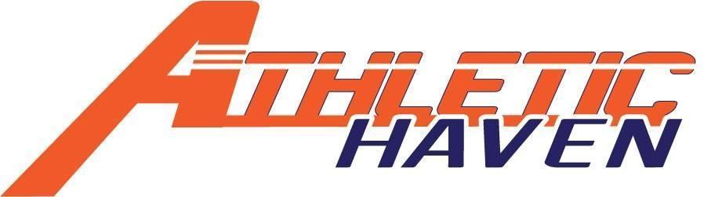
P.O. Box 11524
Albany, New York 12211
518 – 545 – 4876
www.athletichaven.org

JOB DESCRIPTION

Position: Sponsor Coordinator
Reports to: Managing Director / Fundraising Committee Chair
Supervises: N/A
Division: Fundraising
Employment Status: Volunteer
Pay Rate: N/A

Responsibilities:
- Secure sponsors for all Athletic Haven programs and events
- Communicate with sponsors regarding needs, etc.
- Retainment of prior sponsors
- Communicate with Managing Director and Fundraising Chair
- Recommend changes to sponsor tiers if applicable
- Performs other duties as assigned.

Experience, Knowledge, and Skills:
- Excellent sales skills preferred
- Ability to establish and maintain effective working relationships with sponsors.
- Ability to communicate effectively and timely with sponsors and organization.
- Basic knowledge of youth sports preferred.
- Demonstrated creativity and ability to be flexible.

General Member Expectations:
- Maintain the integrity of the organization at all times.
- Represent the organization with pride and dignity at all times.
- Assist with creating and achieving annual fundraising goals
- Maintain good lines of communication with the Managing Director, any direct reports, and peers.
- Be a good role model for both the kids and adults..
- Have a kids’ first mentality!

