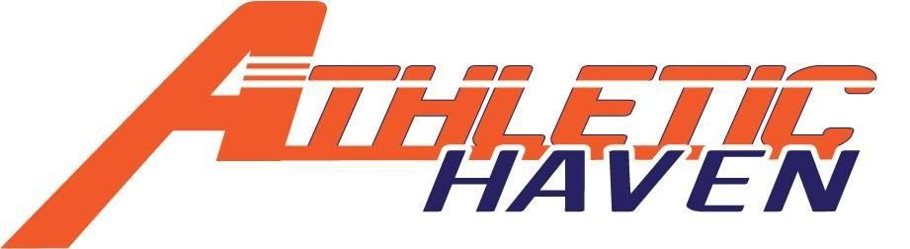
P.O. Box 11524
Albany, New York 12211
518 – 545 – 4876
www.athletichaven.org

JOB DESCRIPTION

Position: Fundraising Committee Chair
Reports to: Executive Director / Board of Directors
Supervises: Fundraising Committee
Division: Fundraising
Commitment: 2 – 3 hours per week
Employment Status: Unpaid Volunteer

Responsibilities:
- Oversees all events, including annual Orange Party
- Lines up and communicates with guest speakers
- Works directly with venues
- Compiles the event roll-out calendar
- Works with Volunteer Coordinator to ensure staffing
- Budget oversight for all events
- Performs other duties as assigned

Experience, Knowledge, and Skills:
- Excellent communication skills, including public speaking for small crowds
- Ability to establish and maintain effective working relationships within and outside the organization
- Ability to organize and prioritize workload
- Demonstrated creativity and ability to be flexible
- Demonstrated event coordination capabilities

General Member Expectations:
- Maintain the integrity of the organization at all times
- Attend Board of Directors and/or Membership meetings as schedule permits
- Maintain good lines of communication with the Managing Director, any direct reports, and the peers
- Strive to assist organization meet, or exceed, annual fundraising and participation goals
- Have a kids’ first mentality!

