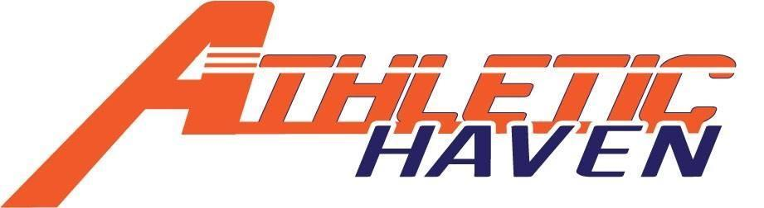
P.O. Box 11524
Albany, New York 12211
518 – 545 – 4876
www.athletichaven.org

JOB DESCRIPTION

Position: Community Liaison
Reports to: Executive Director / Communications Director
Supervises: Marketing Volunteers
Division: Marketing
Commitment: 2 – 4 hours per week
Employment Status: Unpaid Volunteer

Responsibilities:
- Plans, oversees and implements marketing opportunities in the community
- Plans and requests promotional signage and materials for events
- Cross-references postings on social media platforms
- Communicates with organizations and businesses regarding events
- Performs other duties as assigned

Experience, Knowledge, and Skills:
- Excellent communication skills, including public speaking for small crowds.
- Ability to establish and maintain effective working relationships within and outside the organization.
- Ability to organize and prioritize workload.
- Previous experience in the advertising and marketing fields.
- Basic proficiency in marketing softwares & social media platforms
- Basic knowledge of youth sports

General Member Expectations:
- Maintain the integrity of the organization at all times
- Attend Board of Directors and/or Membership meetings as schedule permits
- Maintain good lines of communication with the Executive Director, any direct reports, and the peers
- Strive to assist organization meet, or exceed, annual fundraising and participation goals
- Have a kids’ first mentality!

