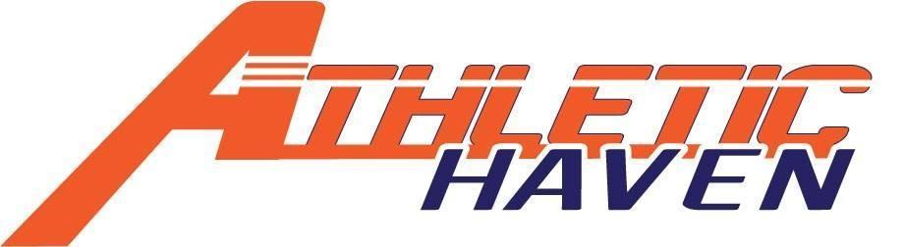
P.O. Box 11524
Albany, New York 12211
518 – 545 – 4876
www.athletichaven.org

JOB DESCRIPTION

Position: Youth Sports Coach
Reports to: Executive Director / Sport Coordinator
Supervises: N/A
Division: Coaching
Employment Status: Part-time, At will & Per Diem- 1099 Contract employee
Pay Rate: $20 / hour
Approximate Hours: 2-3 hours per week

Candidate Availability:
- Weeknights a must
- Some Saturdays
- Seasonal assignments are available
- Hourly commitment

Responsibilities:
- Runs youth basketball or soccer programs
- Set weekly practice plans and session directives
- Maintains stock and condition of any Athletic Haven equipment
- Learn and implement venue procedures
- Reports to Executive Director on a weekly basis (via email or text)
- Performs other duties as assigned

Experience, Knowledge, and Skills:
- Excellent skills with kids of all ages.
- Ability to establish and maintain effective working relationships within and outside the organization.
- Ability to create, organize and diversify practice plans
- Candidate should possess at least basic knowledge in the sport of basketball
- Demonstrated creativity and ability to be flexible.

General Member Expectations:
- Maintain the integrity of the organization at all times.
- Be a good role model for both the kids and adults.
- Provide a positive, enriching experience at all Athletic Haven programs
- Maintain good lines of communication with the Managing Director, any direct reports, and peers..
- Have a kids’ first mentality!

