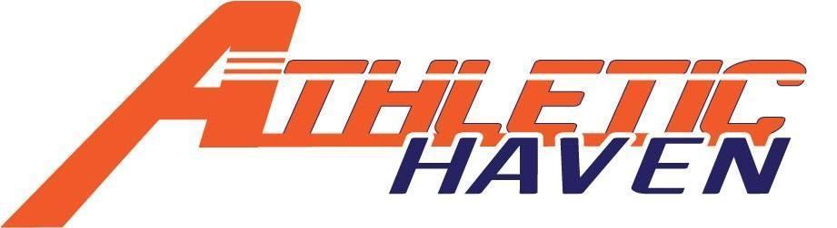P.O. Box 11524

Albany, New York 12211

518 – 545 – 4876

[www.athletichaven.org](http://www.athletichaven.org)

**JOB DESCRIPTION**

**Position:** Part-Time Coach

**Reports to:** Executive Director

**Supervises:** N/A

**Division:** Coaching

**Employment Status:** Part-time, At will & Per Diem- 1099 Contract employee

**Pay Rate**: $20 / hour

**Approximate Hours:** 4 hours per week

**Candidate Availability:**

* Weekday evenings from 5:30-8:30p
* There could be occasional weekend hours needed
* Hourly commitment

**Responsibilities:**

* Runs youth basketball programs
* Set weekly practice plans and session directives
* Maintains stock and condition of any Athletic Haven equipment
* Learn and implement venue procedures
* Reports to Executive Director on a weekly basis (via email or text)
* Performs other duties as assigned.

**Experience, Knowledge, and Skills:**

* Excellent skills with kids of all ages.
* Ability to establish and maintain effective working relationships within and outside the organization.
* Ability to create, organize and diversify practice plans
* Candidate should possess at least basic knowledge in the sport of basketball
* Demonstrated creativity and ability to be flexible.

**General Member Expectations:**

* Maintain the integrity of the organization at all times.
* Be a good role model for both the kids and adults.
* Provide a positive, enriching experience at all Athletic Haven programs
* Maintain good lines of communication with the Managing Director, any direct reports, and peers..
* Have a kids’ first mentality!